No. of Pages | 6
No. of Questions | 7

Department of Computer Science and Engineering
FINAL EXAMINATION SPRING 2012

CSE490: LAN Switching and WAN Technologies
Total Marks:75 Time Allowed: 3 Hours

- Answer any FIVE (5) questions out of the given SEVEN(7) questions.
- Figure in bracket [] next to each question indicates marks for that question.

Question No. 1

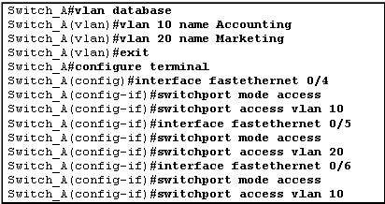
Figure No. 1

- Refer to the figure no. 1 above, explain the purpose of the commands. Where does the switch save all the vlan information? [4 marks]
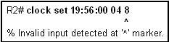
Figure No. 2

- What does the error message imply in figure no. 2? State some helping commands or messages that allow us easily to configure a switch in the CLI mode. [3 marks]
SW1(config-if)#switchport trunk native vlan 90
SW1(config-if)#switchport trunk allowed vlan add 99,100,101

Figure No. 3

- Explain the above commands shown in figure no.3. What difference will it make if the second command is not given? [3 marks]
- What is the difference between data VLAN and voice VLAN? [3 marks]
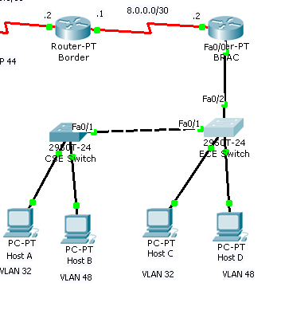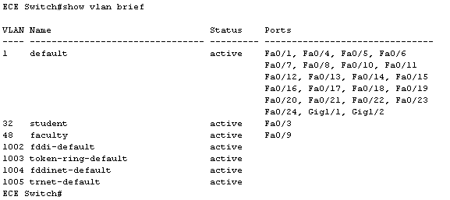
Figure No. 4(b)
Figure No. 4(a)

- Refer to the exhibit above in figure no. 4(a) and 4(b), Host A and Host B are unable to communicate with anybody. Can you find the problem from the output shown in figure no. 4(b)? [2 marks]

Question No. 2
R(config)#interface f0/1.2
R(config-subif)#encapsulation dot1q 20
R(config-subif)#ip add 172.18.0.1 255.255.255.128
R(config-subif)#interface f0/1.3
R(config-subif)#encapsulation dot1q 30
R(config-subif)#ip add 172.18.0.161 255.255.255.224
R(config-subif)#interface f0/1.4
R(config-subif)#encapsulation dot1q 40
R(config-subif)#ip add 172.18.0.193 255.255.255.224
R(config-subif)# interface f0/1
R(config-if)#no shutdown

Figure No. 5

- Refer to the commands shown in the above figure no. 5, explain the “encapsulation dot1q 20” command. Why was the “no shutdown” command given to only interface f0/1? [4 marks]
- Referring to the commands shown in figure no. 5, suppose that the router receives a frame on physical interface f0/1.The source IP is 172.18.0.4/27 and the destination IP address is 172.18.0.200/27. What will the router do and why? [4 marks]

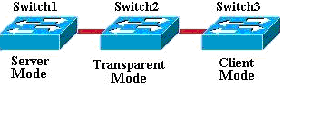
Figure No. 6
- In the above figure no. 6, two new VLANs are created in the server switch. After addition of the new VLANs to the vlan.dat of the server switch, what type of VTP messages will be send between the switches? What is the difference between Switch 2 and Switch 3 in dealing with the messages? [4 marks]
- A client switch is reset. How does it obtain VLAN information? [3 marks]

Question No. 3
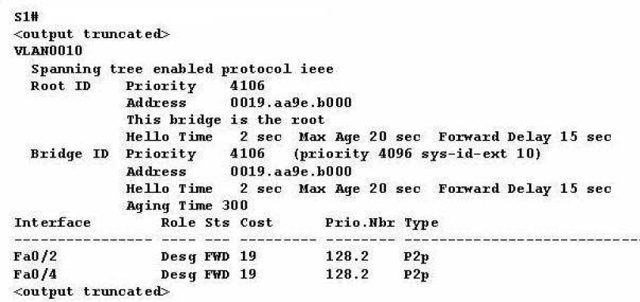
Figure No. 7

- Refer to the exhibit above in figure no. 7; what can be determined from the output shown? Why are there no root ports? [4 marks]
- A broadcast storm has occurred in a switched network. Why? What can you do to stop the broadcast storm at that moment and what can you do to prevent this broadcast storm from occurring again? [4 marks]
- If a switch has two ports with the same cost route to the root bridge, which of these ports will become the root port? Usually what factors are considered to calculate the cost of a path or port? [4 marks]
- What is the difference between forwarding state and learning state? [3 marks]

Question No. 4

- What rules do we follow to place standard and extended ACLs? What happens if you forget to place the ACLs? [3 marks]
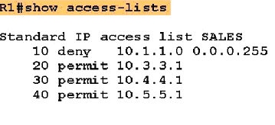
Figure No. 8
- What kind of ACL is shown in the above output in figure no. 8? I want insert another ACL in between “deny 10.1.1.0 0.0.0.255” and “permit 10.3.3.1” statements. How can I do it? [3 marks]
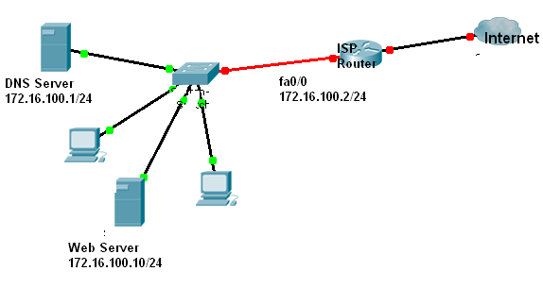
Figure No. 9

- Configure a named ACL called NO_PING so that all hosts from the outside can access the web server (at 172.16.100.10) through http but cannot ping the web server using figure no. 9. DON’T forget to place the ACL. [5 marks]
- Refer to the figure no. 9 above; you are to allow telnet to the ISP router only from 200.20.20.0/28 network. All other traffic is prohibited. Do it using a standard ACL. [4 marks]

Question No. 5
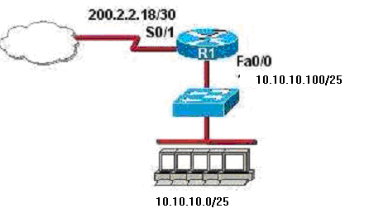
Figure No. 10

- Refer to the figure no. 10 shown above, write the commands, that are necessary to dynamically assign the inside address space, 10.10.10.0/25, to a NAT pool of 200.2.2.16/28. [4 marks]

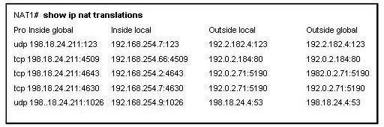
Figure No. 11

- The above output shown in figure no. 11, shows entries of what, explain. [3 marks]
- What is Static NAT? Where is it applicable? Explain by giving an example. [4 marks]
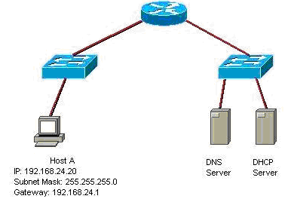
Figure No. 12

- Using the above network shown in figure no.12; what are the steps required to enable the Router as a DHCP server and remove the DHCP server shown. You can narrate steps or write the commands necessary. [4 marks]

Question No. 6

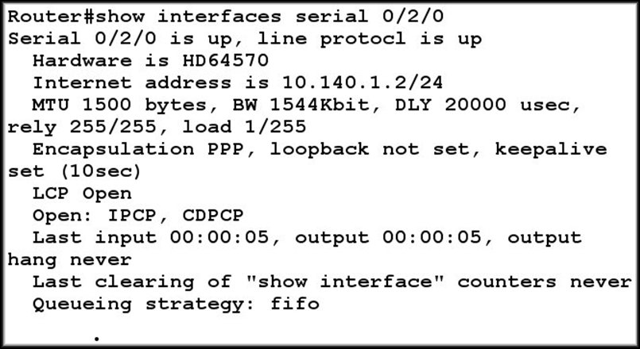
Figure No. 13
- Referring to the output shown in figure no.13, explain the lines “LCP open” and “Open:IPCP, CDPCP” [3 marks]

- How is a PPP session established? What are the phases involved? [4 marks]
- Why is CHAP better than PAP? What happens next when the Remote router sends the challenge packet to the Local router in CHAP authentication process? [5 marks]
- State what do the following commands mean? [3 marks]
- Router(config-if)#ppp quality 90
- Router(config-if)#ppp compress stacker
- Router(config-if)# ppp multilink

Question No. 7

- The output shown in figure no. 14, shows what? What do the words static and dynamic imply? [4 marks]

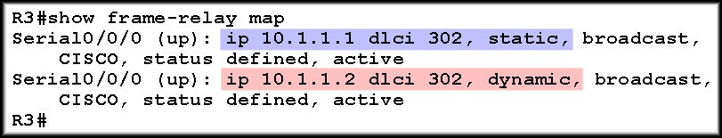
Figure No. 14

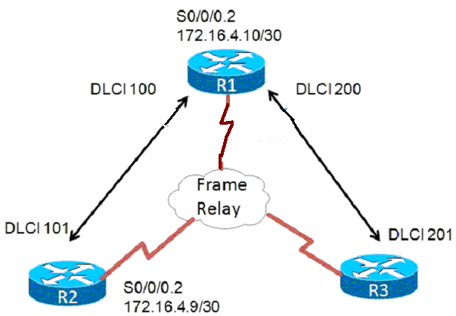
Figure No. 15

- For figure no.15, the link between R1 and R2 is represented with two different DLCI numbers 100 and 101, why? [3 marks]
Router1(config)#int s0/0/0.2 point to point
Router1(config-if)#ip address 172.16.4.10 255.255.255.252
Router1(config-if)# frame-relay interface-dlci 100
Router1(config-if)# bandwidth 64

Figure No. 16

- The partial commands shown above in figure no. 16 were issued in Router1, why was a sub interface created? Also explain the purpose of the commands. [4 marks]

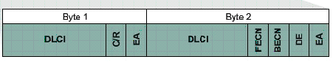
Figure No. 17
- The above figure no. 17 shows the address part of the frame relay frame. Explain the purposes of the bits FECN and BECN shown in the circle. [4 marks]

THE END

